Lab No. 13
Part I - Lab Tasks:
- Step 1 to 3: Import Packages, Build Dataset, and Explore
We will import our data science tools and the KMeans class from scikit-learn.
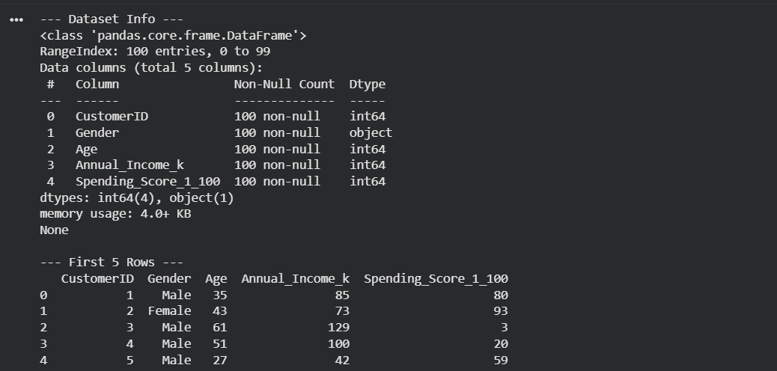

Step 4: Feature Selection
To accurately map customer profiles on a 2D plot, we will isolate the two most vital behavioral attributes : Annual Income and Spending Score.
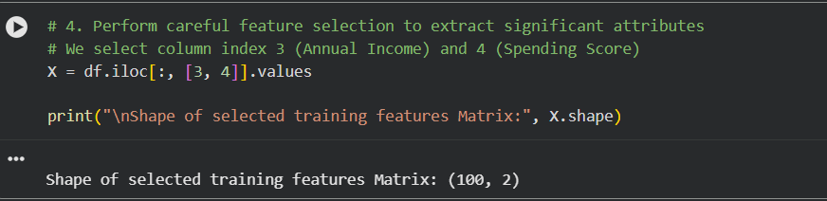

Step 5 & 6: Find Optimal Clusters ($K$) using the Elbow Method
Before running K-Means, we must decide on the number of clusters ($K$). We run an iterative loop computing the Within-Cluster Sum of Squares (WCSS) to find the "elbow" point.
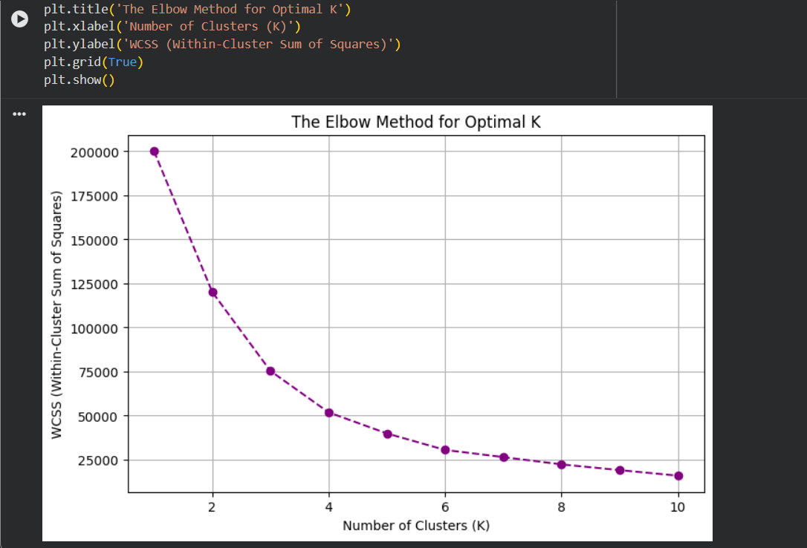

Step 7: Instantiate and Train the K-Means Model
Based on the elbow graph look, $K=5$ is typical for mall customer segmentation. We instantiate our final model object and feed it our selected structural data matrix.
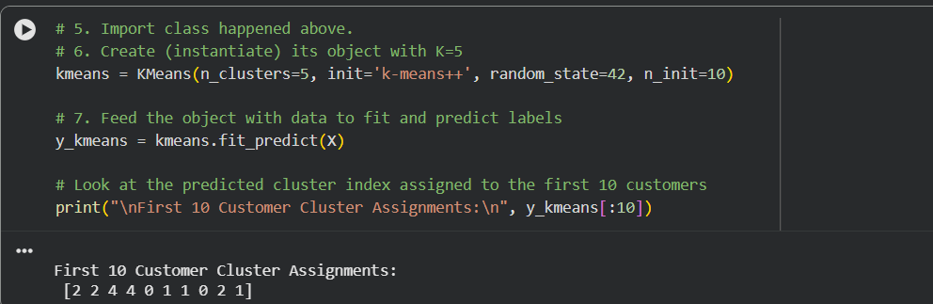

Step 8: Visualizing the Obtained Clusters
We plot our data points split by color groups and overlay their respective cluster centroids.
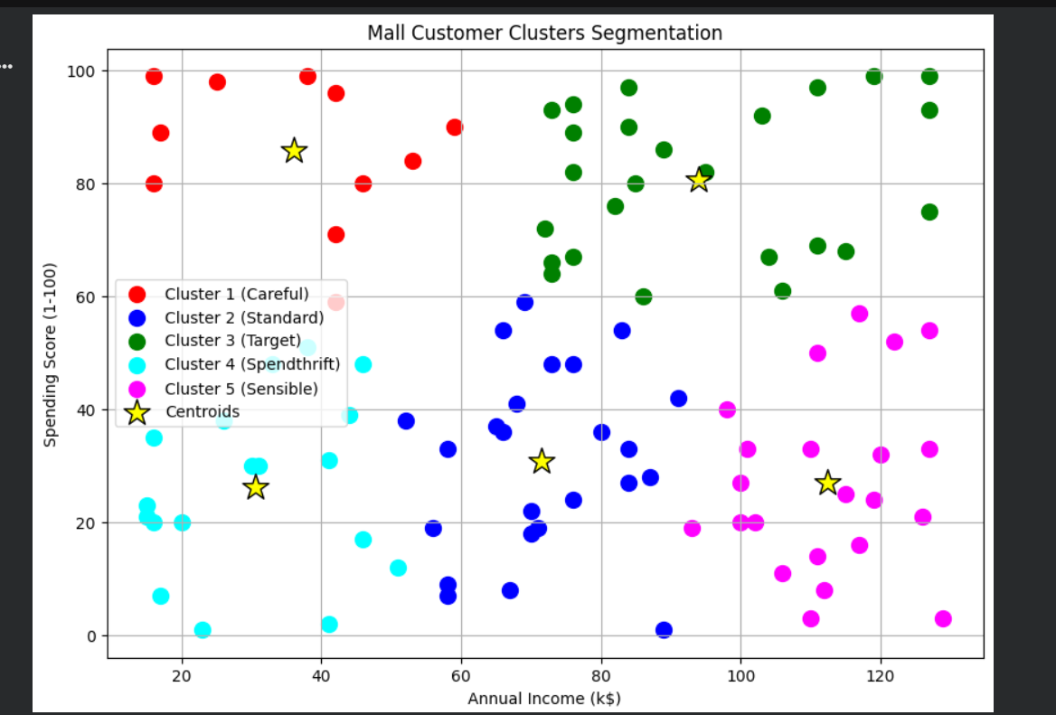

Part II – Home Assignment Solutions:

Explain K-Median Method for Clustering
The K-Medians Clustering algorithm is a variations alternative to K-Means. The primary architectural variations are:
- Centroid Metric: Instead of calculating the mean (average) value of data points to move the cluster center, it calculates the median value across each feature dimension.
- Distance Metric: K-Means uses standard straight-line Euclidean Distance ($L_2$ norm). K-Medians minimizes the absolute error using Manhattan Distance ($L_1$ norm).
Why use it? Medians are far more robust to statistical anomalies than means. If your retail dataset contains extreme outlier customers (e.g., a multi-millionaire shopping at a modest venue), K-Means centroids will skew drastically toward that outlier, whereas K-Medians will hold its center steady.

Algorithms Related to the 4 Clustering Methods
Your lab text organizes clustering methods into four major conceptual families:

Clustering Type PDF | Underlying Concept PDF | Notable Algorithm Examples
Centroid-based | Organizes data around central vectors (centroids). Closeness defines membership. | * K-Means  * K-Medians  * K-Medoids (PAM)
Connectivity-based | Based on the core idea that objects closer in space are more related than objects farther apart. | * Hierarchical Agglomerative Clustering (Bottom-Up)  * Divisive Clustering (Top-Down)
Density-based | Defines clusters as high-density continuous spatial regions separated by low-density noise regions. | * DBSCAN (Density-Based Spatial Clustering of Applications with Noise)  * OPTICS
Distribution-based | Models clusters based on the probability that data points fit into the same statistical distribution. | * Gaussian Mixture Models (GMM)  * Expectation-Maximization (EM) Clustering

